H.T No
Regulations:
A15


Sreenidhi Institute of Science and Technology
(An Autonomous Institution)
Code No:5C446 Date: 25-Jan-2020 (FN)

B.Tech II-Year II-Semester External Examination, Jan/Feb - 2020 (Supplementary)
ELECTRONIC CIRCUITS (EEE)

Time: 3 Hours Max.Marks:75

Note: a) No additional answer sheets will be provided.
b) All sub-parts of a question must be answered at one place only, otherwise it will not be valued.
c) Missing data can be assumed suitably.

Part - A Max.Marks:25

Answer all QUESTIONS.

1. | Mention the ideal characteristics of a buffer. | [3M]
2. | What is the role of coupling capacitor in an amplifier? | [3M]
3. | Draw the circuit diagram of current shunt feedback amplifier. | [3M]
4. | How does Hartley oscillator differ from a Colpitt’s Oscillator in construction? | [3M]
5. | Sketch the voltage transfer characteristics for the following circuit with Vi=10Vp-p and V_{R} =2V.(Assume the diode is ideal)  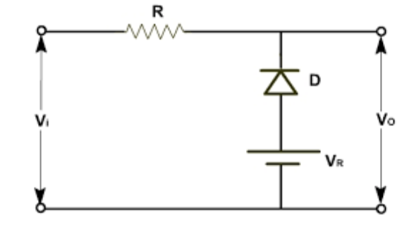 | [3M]
6. | How a low pass RC circuit acts as an integrator | [2M]
7. | Describe briefly about forward recovery time T_{fr}. | [2M]
8. | Why a Monostable Multivibrator also called as one shot multi-vibrators. | [2M]
9. | Draw the circuit diagram of class B push pull transformer coupled power amplifier | [2M]
10. | Why power amplifiers are also called as large signal amplifiers | [2M]
Part – B Max.Marks:50
ANSWER ANY FIVE QUESTIONS. EACH QUESTION CARRIES 10 MARKS.

11. | a) | Estimate the A_{v}, A_{i}, R_{i} and R_{o} for CC amplifier using low frequency approximate analysis | [5M]
 | b) | Define f_{β} and f_{T} .Explain the relation between them. | [5M]
12. | a) | Explain a neat block diagram of negative feedback amplifier and draw the sampling topologies. | [6M]
 | b) | An amplifier has a mid-frequency gain of 100 and a bandwidth of 200KHz.  (i) what will be the new bandwidth and gain, if 5% negative feedback is introduced? (ii) What should be the amount of feedback, if the bandwidth is to be restricted to 1MHz? | [4M]
13. | a) | Draw and explain the operation of Colpitt’s Oscillator using BJT and write the condition for sustained oscillations | [5M]
 | b) | Determine the range of inductance values, if the frequency of oscillations is to vary between 950KHz and 20,580KHz for Colpitt’s Oscillator is designed with C₁ =100Pf and C₂= 7500Pf | [5M]
14. | a) | Sketch the response and voltage transfer characteristics for the following circuits (assume the diodes are ideal with reference voltage V_{R} = V_{B} = 2V, V₁ = 10 V_{P-P})  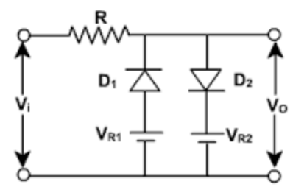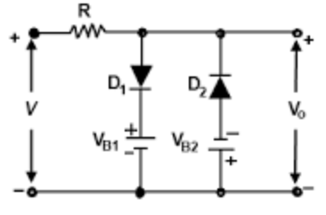 | [4M]
 | b) | A negative clamper has a 8V, 50Hz square wave input with a 600Ω signal source resistance, the output wave form is to have maximum tilt of 1%. Determine R and C? | [6M]
15. | a) | Explain the importance of diode switching times. | [5M]
 | b) | Explain the Break down mechanism for a heavily doped PN junction diode. | [5M]
16. |  | Explain and Derive the expression for output pulse width of an emitter coupled Mono stable Multi Vibrator with necessary diagrams. | [10M]
17. | a) | Explain the detail operation of complimentary symmetry class B push pull power amplifier and mention its advantages and disadvantages. | [6M]
 | b) | A class B push pull amplifier must deliver 10W of audio power to the output load, if the output transformer is 80% efficient, what is the minimum power drain on the power supply under optimum conditions | [4M]
18. | a) | Explain the operation of series fed Class –A power amplifier and estimate the overall conversion efficiency | [6M]
 | b) | Determine the Maximum output power and maximum collector efficiency for a transformer coupled class-A power amplifier which draws a current of 200mA from collector supply of 10V. | [4M]

-- 00 -- 00 –

